**Command and Control**

*Response Cluster*

National Disaster Risk Reduction and Management Council

QUALITY @ Asia Pacific College S.Y. 2016 – 2017

**Course Instructor:**

* + Mr. Edmundo Casiño SOFTDEV and QUALITY Professor

**Project Team:**

* + Carl Dominique Bueno Project Manager/Developer
  + Maica Belchez Project Analyst/Documenter
  + Abigail Malapo Assistant Documenter/Quality Tester
  + Jorome Mortera Assistant Documenter/Quality Tester

**Client Information:**

Company/Organization Name: National Disaster Risk Reduction and  
 Management Council (NDRRMC)

Department of Social Welfare and  
 Development (DSWD)

Project Name: Command and Control

Response Cluster

Primary Contact Person: N/A

Position: N/A

**About Command and Control Response Cluster:**

Lead Agency: Philippine National Police (PNP)

Member Agency(s): Armed Forces of the Philippines (AFP)

Department of Foreign Affairs (DFA)

Office of the Civil Defense (OCD)

Department of the Interior and Local Government (DILG)

Department of Health (DOH)

Metropolitan Manila Development Authority (MMDA)

Regional Emergency Assistance Communications Team (REACT)

National Bureau of Investigation (NBI)

Philippine Red Cross (PRC)

Bureau of Fire Protection (BFP)

Department of Public Works and Highways (DPWH)

Philippine Coast Guard (PCG)

International Federation of Red Cross (IFRC)

International Committee of the Red Cross (ICRC)

United Nations Disaster Assessment and Coordination

1. **Overview**

**Project Description**

*Mission Statement*

Maintaining peace and order on disaster circumstances. Therefore, providing an effective and integrated response to disaster situations through execution of standard procedures and protocols and a centralized disaster management system.

*Problem Statement*

Disaster is just around the corner and it may possibly happen anytime, local government units are expected to be at the frontline of emergency measures in the aftermath of disaster. Hence, government lacks on integration of disaster assessments to be drawn from local to national level and standard disaster protocols to execute an operative response action. Identifying the alert systems to be declared within the affected area for obligatory actions from local to national level of the government.

Another problem exist to present situation are the methods and criteria of determining the type of disaster and its risks, the level of damage, identifying the number of victims and evaluating the condition of the area. Moreover, disaster response includes suitable relief services and assistance to be provided by different sectors and volunteers.

**Objectives:**

Our project team will provide proof of concepts on determining the alert level of risk from local to national level through forming a disaster assessment form. In addition is the structure of command and control sub-headquarters to be deploy per government level that will evaluate the assessments per affected City, Province and Region.

**Project Scope**

* Identify the disaster and area affected
* Identify the hazard category and governance level
* Determine the rate of damage and victims affected
* Deploy relief services and support functions
* Communication between the respondents
* Centralized disaster assessment management system

**Limitations**

* Assessing volunteer must be registered as Disaster Coordination Council Officer per area of coverage
* Network Connectivity for transmission of data to sub-headquarters

**Review of Related Literature**



A proprietary mobile app which uses wireless mesh networking (Bluetooth or Wi-Fi) to enable smartphones communicate even without network or Internet connection.

Traditionally, users sent messages to each other through data or Wi-Fi networks. The messages are sent through a mobile network to a hotspot or cell phone tower. The data sent through to these data towers or Wi-Fi hotspots are then relayed through a centralized network and eventually the messages or data is received. During all this data transfer period, your VPN is tracked. Though you can use a VPN service to protect your mobile data, information about your network can be tracked. Unlike most chatting apps, the FireChat doesn’t rely solely on Wi-Fi or data – it doesn’t even need a hotspot or centralized mobile network to relay data. Instead, the app relies on peer-to-peer connections through wireless mesh networking via Bluetooth or Wi-Fi, technology built in the phone. If the FireChat users are within 100 feet of each other, they can connect and share messages.

FireChat is a free mobile app that works where other apps can’t: when there are no cell networks or Internet access. How is that possible? The app uses the radios inside phones to let users connect to each other for free, via Bluetooth and direct Wi-Fi, without going through a telecom operator. The more people use it, the better it gets. When there is no Internet, for example at a music event, on the train, on a plane, or at a sports game, you can continue chatting and sharing pictures with the people around you. This is called “The Internet of Us”. It’s peer-to-peer networks gone mainstream, just like peer-to-peer to share music.



Eden is a flexible humanitarian platform with a rich feature set which can be rapidly customized to adapt to existing processes and integrate with existing systems to provide effective solutions for critical humanitarian needs management either prior to or during a crisis. Sahana Eden’s features are designed to help Disaster and Emergency Management practitioners to better mitigate, prepare for, respond to and recover from disasters more effectively and efficiently. Sahana Eden can provide valuable solutions for practitioners in Emergency Management, Humanitarian Relief and Social Development domains.

Sahana Software was initially developed by members of the information technology (IT) community in Sri Lanka to provide solutions for the relief effort following the 2004 Indian Ocean Tsunami. Sahana Eden is the latest evolution of this software and provides a solution to manage organizations, people, projects, inventory and assets as well as collecting information through assessments and providing situational awareness through maps. Sahana Eden can be accessed from the web or locally from a flash drive, allowing it to be used in environments with poor internet. Local & Web versions can be configured to synchronize to allow data to be shared between them. Sahana Eden is a project of the Sahana Software Foundation, whose mission is: To help alleviate human suffering by giving emergency managers, disaster response professionals and communities access to the information that they need to better prepare for and respond to disasters through the development and promotion of free and open source software and open standards. The project is supported by a voluntary community of Disaster Management practitioners, students, academics and companies. This community can provide a basic level of support to help you deploy and configure Sahana Eden. There are also companies, such as AidIQ, who provide professional services to customize and support Sahana Eden.

1. **Stakeholders**

**Course Instructor:**

* Mr. Edmundo Casiño SOFTDEV and QUALITY Professor

**Project Team:**

* Carl Dominique Bueno Project Manager/Developer
* Maica Belchez Project Analyst/Documenter
* Abigail Malapo Assistant Documenter/Quality Tester
* Jorome Mortera Assistant Documenter/Quality Tester

**Client Information:**

Company/Organization Name: National Disaster Risk Reduction and  
Management Council (NDRRMC)

Department of Social Welfare and  
 Development (DSWD)

Project Name: Command and Control

Response Cluster

Primary Contact Person: N/A

Position: N/A

**Roles and Responsibilities**

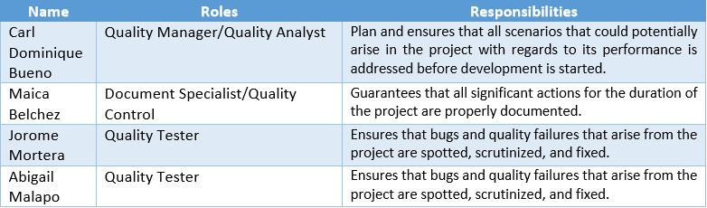

1. **Software Requirement Specification**

***Quality Assurance Checklists***

***User Interface (Dashboard)***

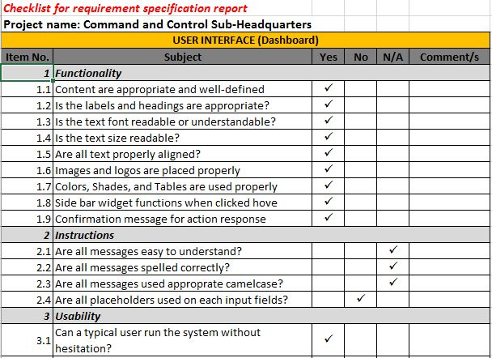

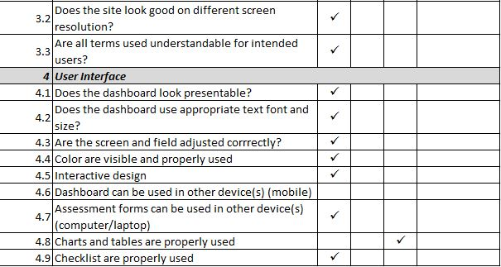

***Functionality (Dashboard)***

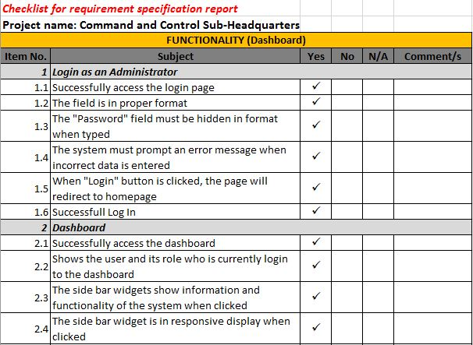

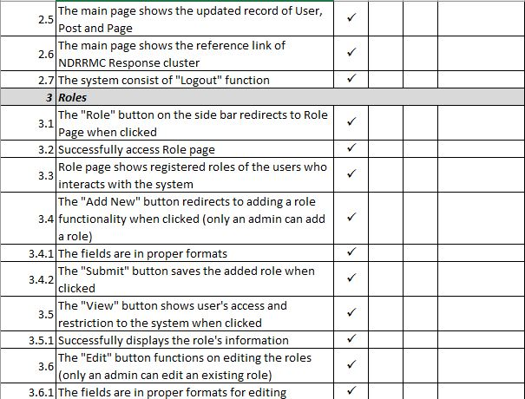

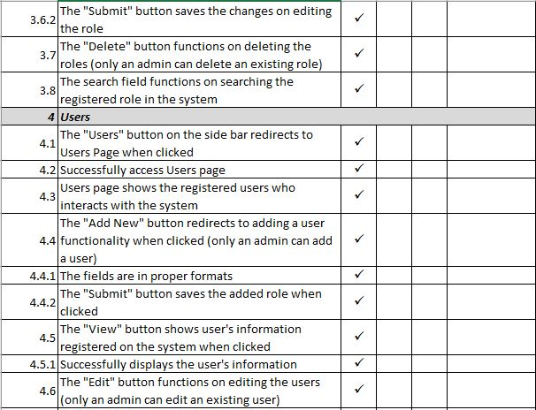

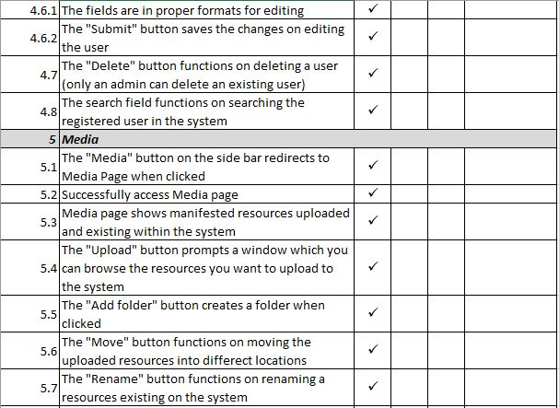

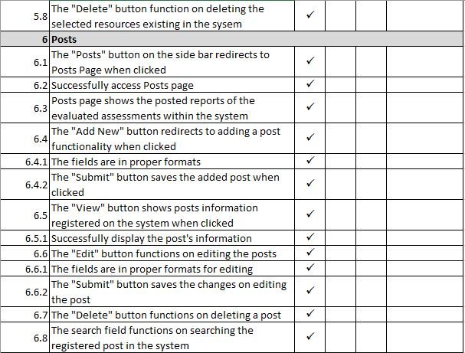

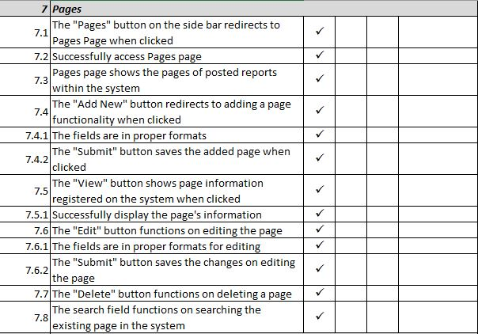

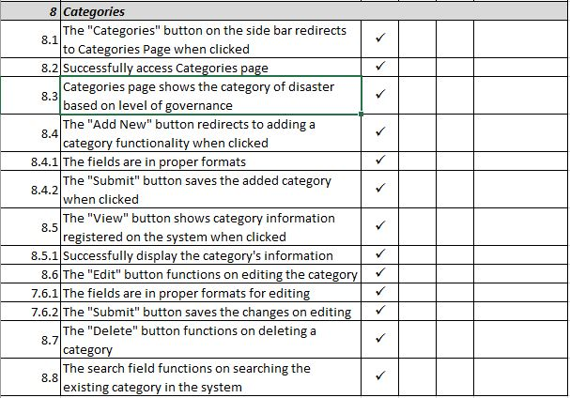

***User Interface (MobileApp)***

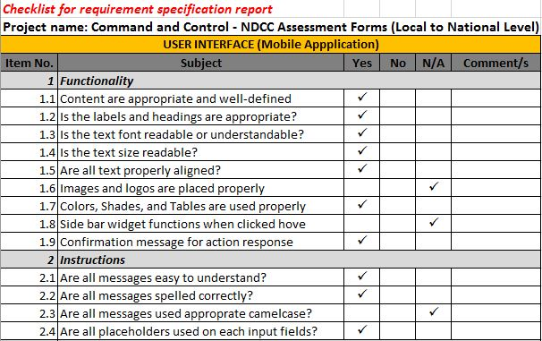

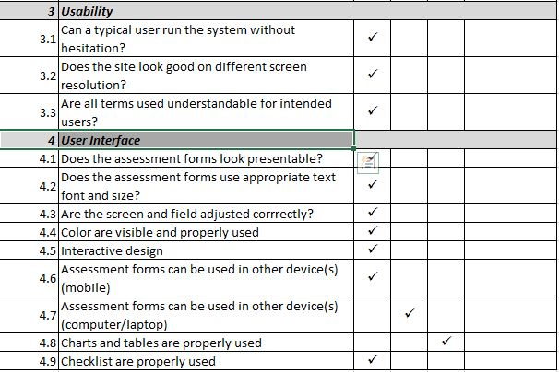

***Functionality (MobileApp)***

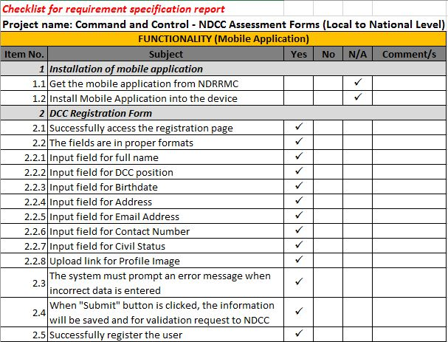

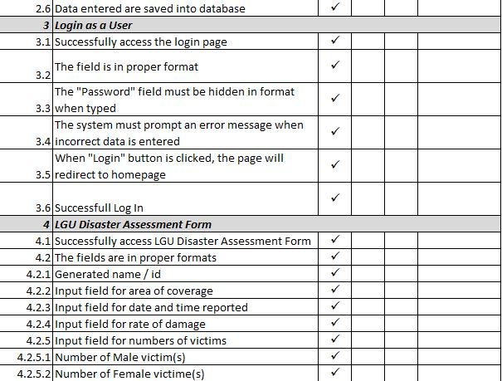

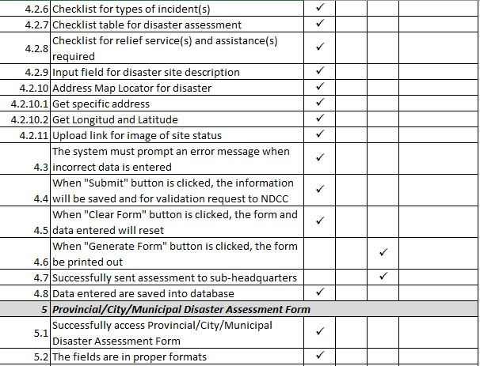

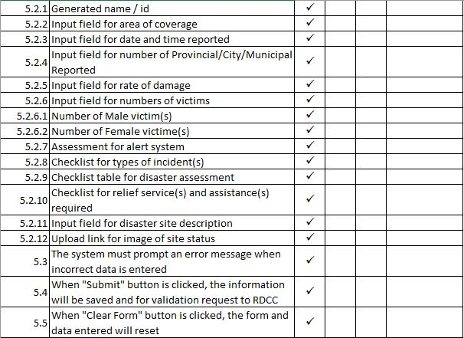

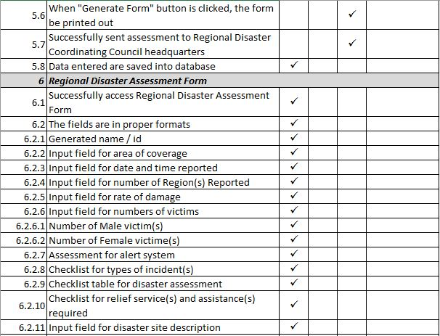

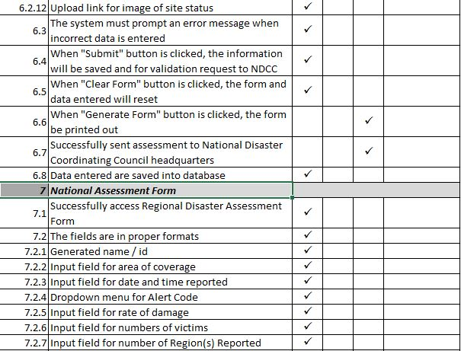

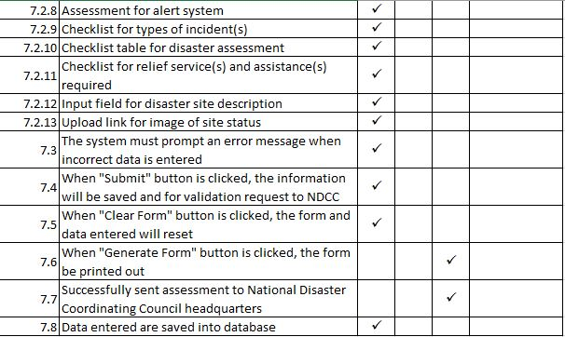

1. **Test Plan**

***Quality Test Cases***

***Login Dashboard***

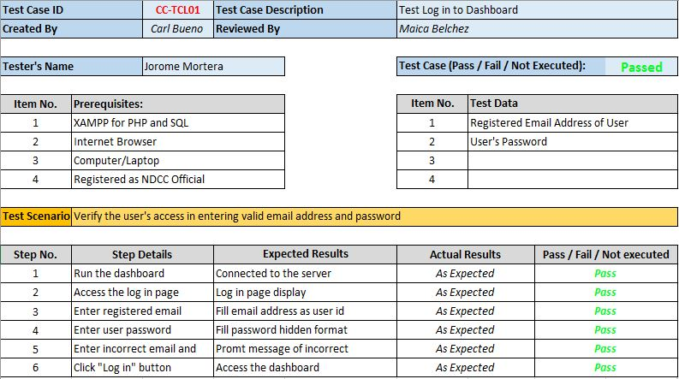

***Dashboard Functionalities***

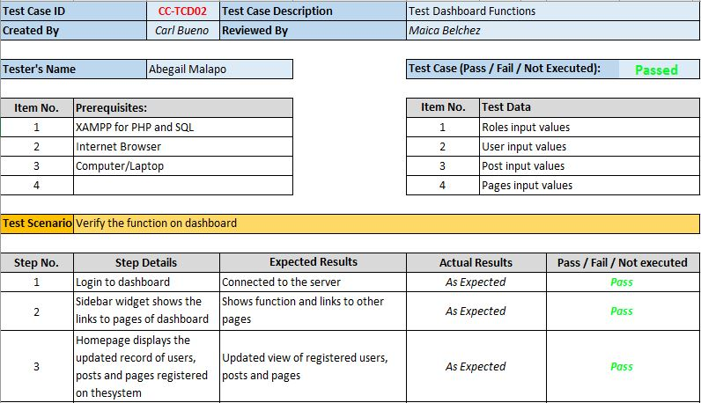

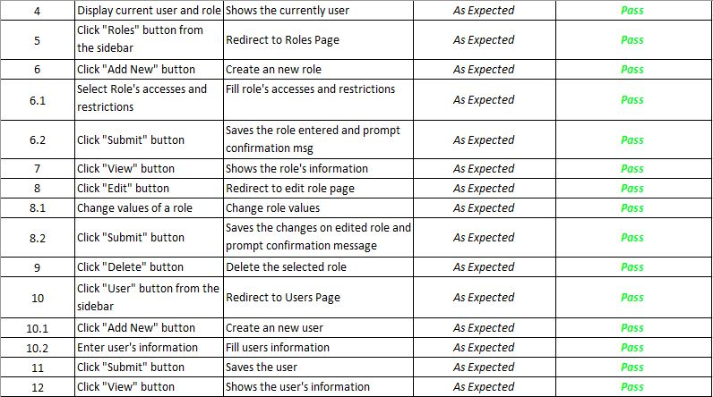

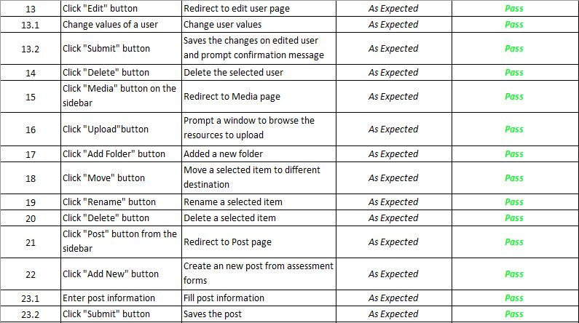

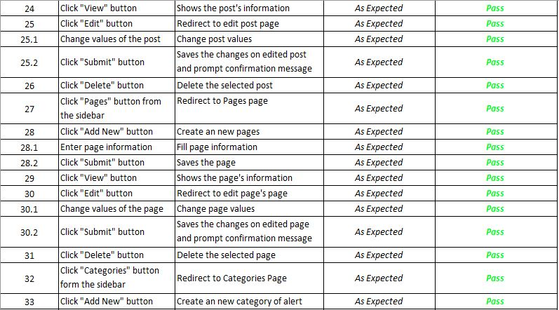

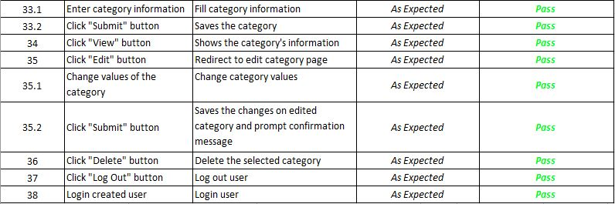

***Disaster Coordinating Council Officer Registration (MobileApp)***

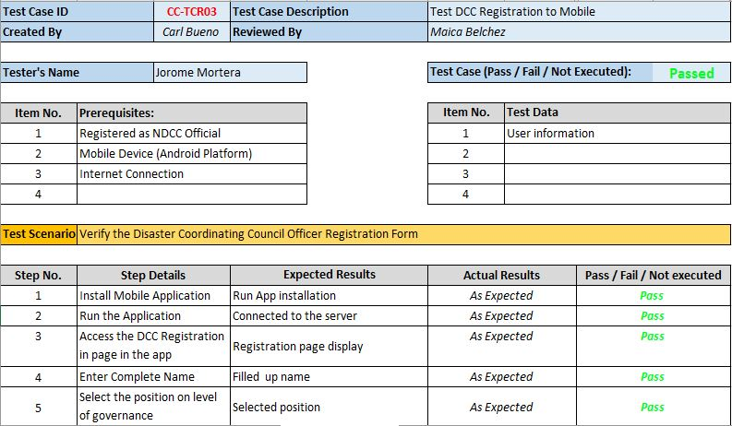

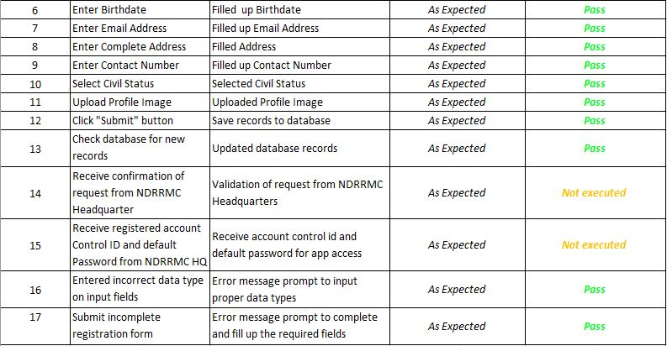

***Login as User (Mobile)***

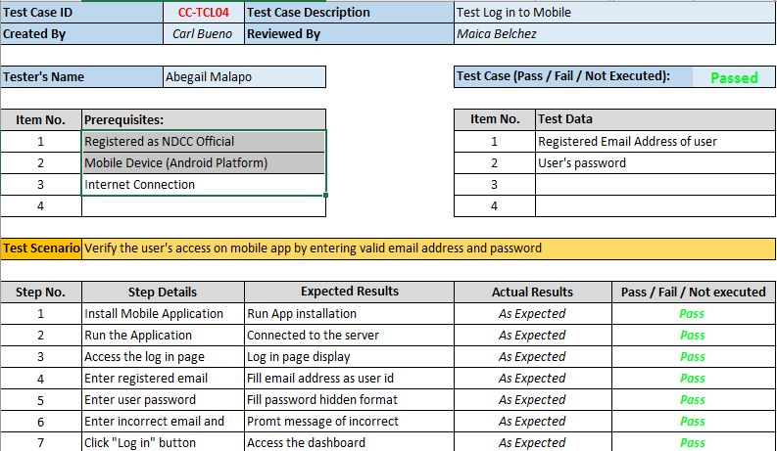

***Assessment on Mobile***

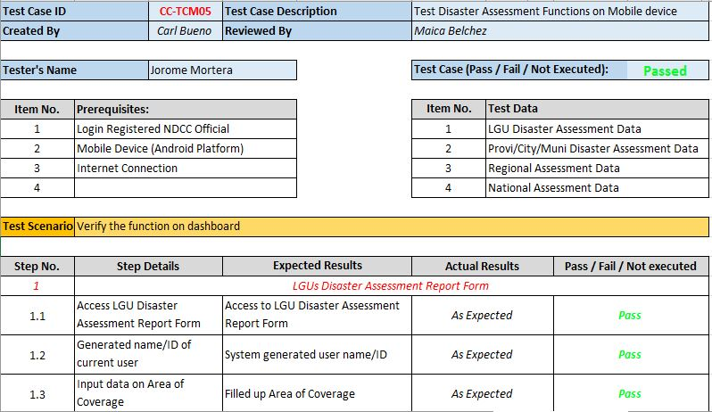

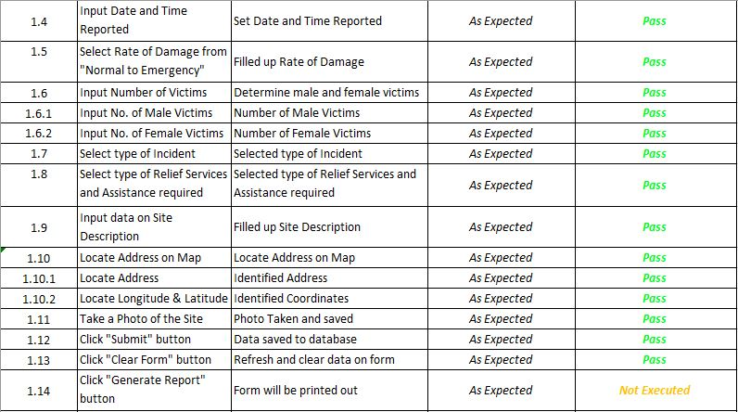

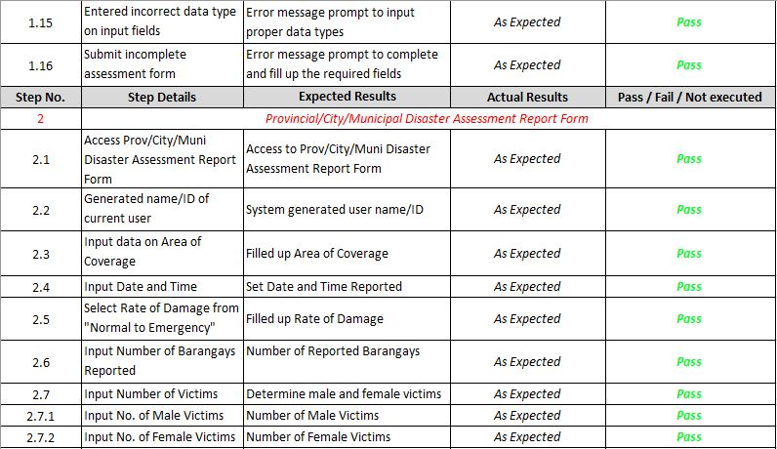

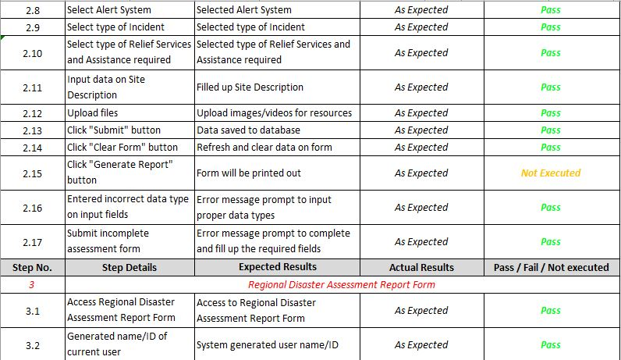

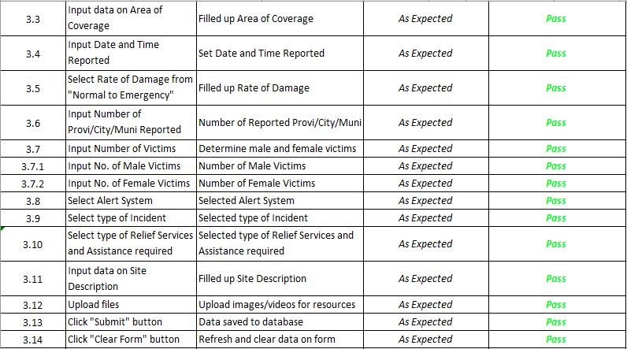

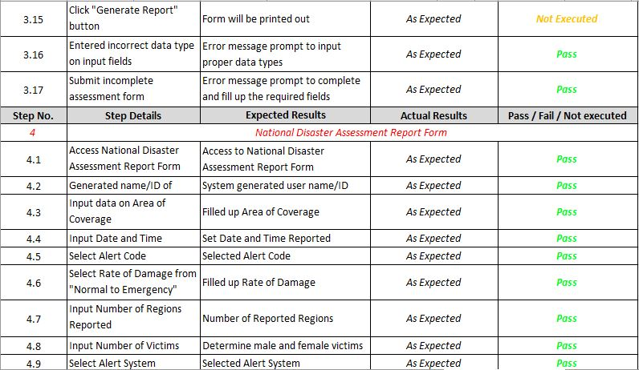

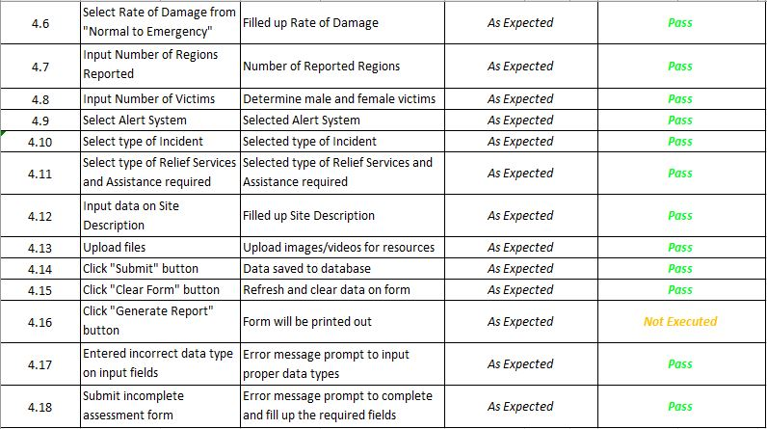

1. **Appendices**

**System Diagrams**

***Over-all System Architecture of Response Cluster***

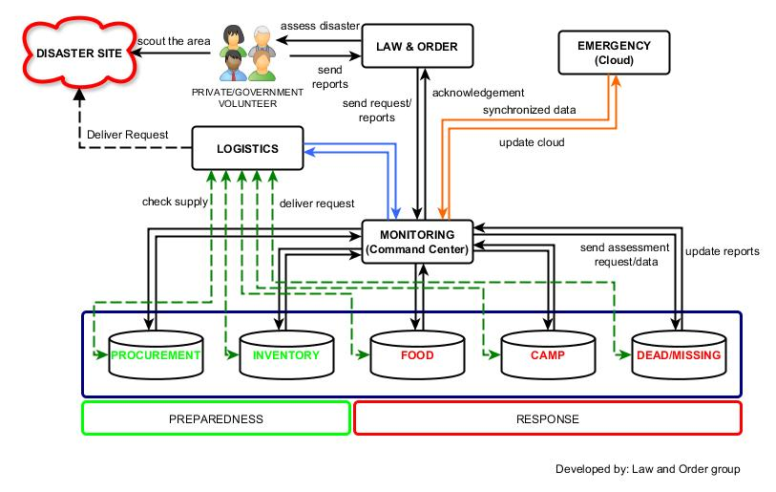

***Context-Flow Diagram (System)***

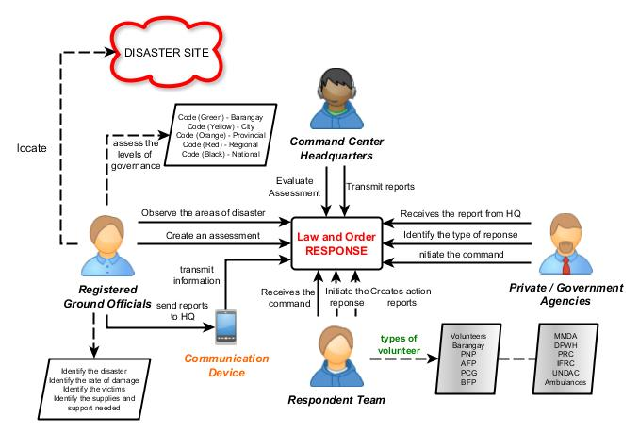

***Context-Flow Diagram (User)***

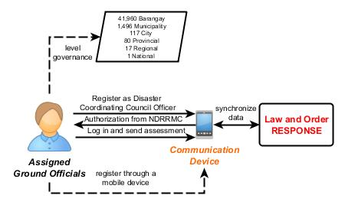

***Data Flow Diagram (System)***

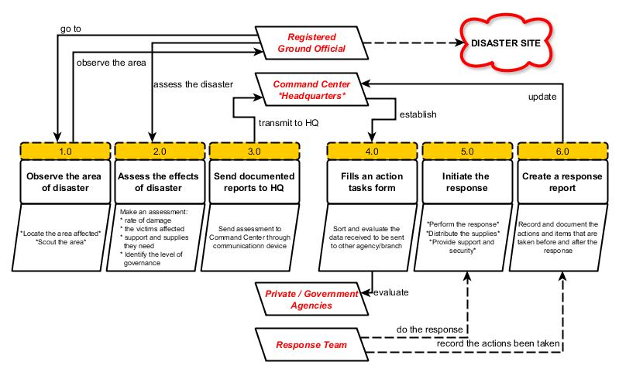

***Data Flow Diagram (User)***

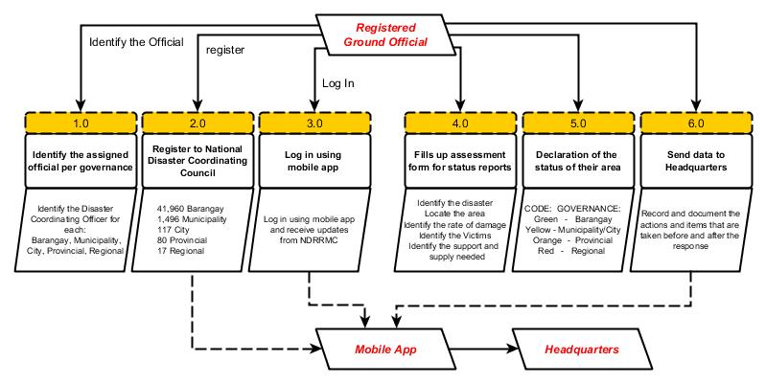

***User Case Diagram (System)***

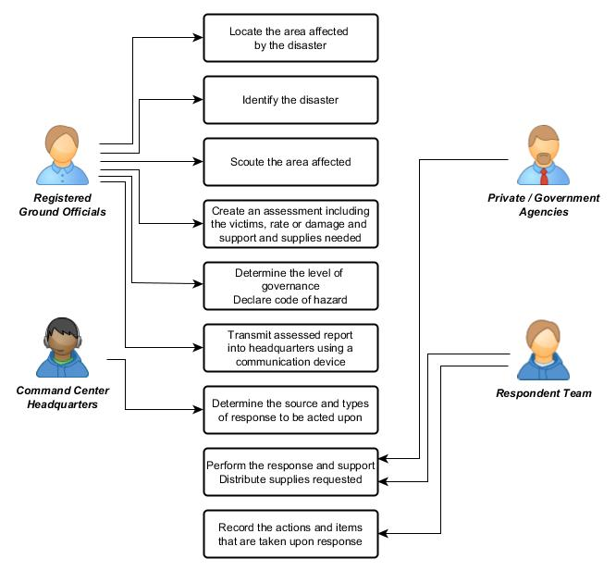

***User Case Diagram (User)***

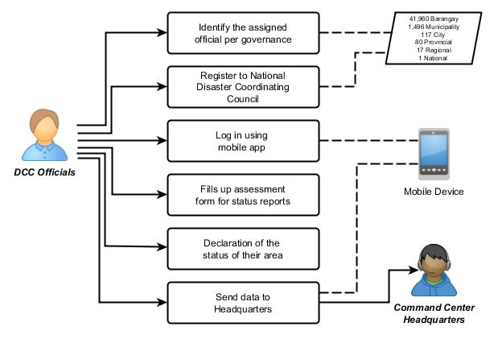

***Event Table***

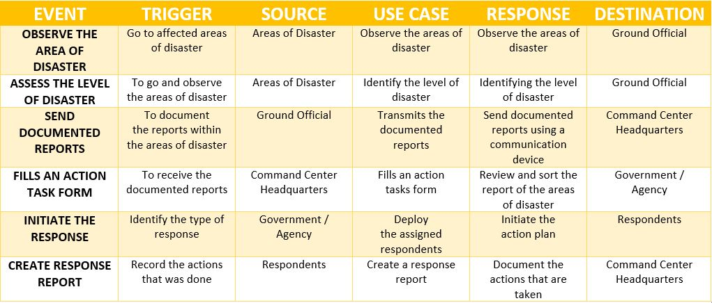

***Entity-Relationship Diagram***

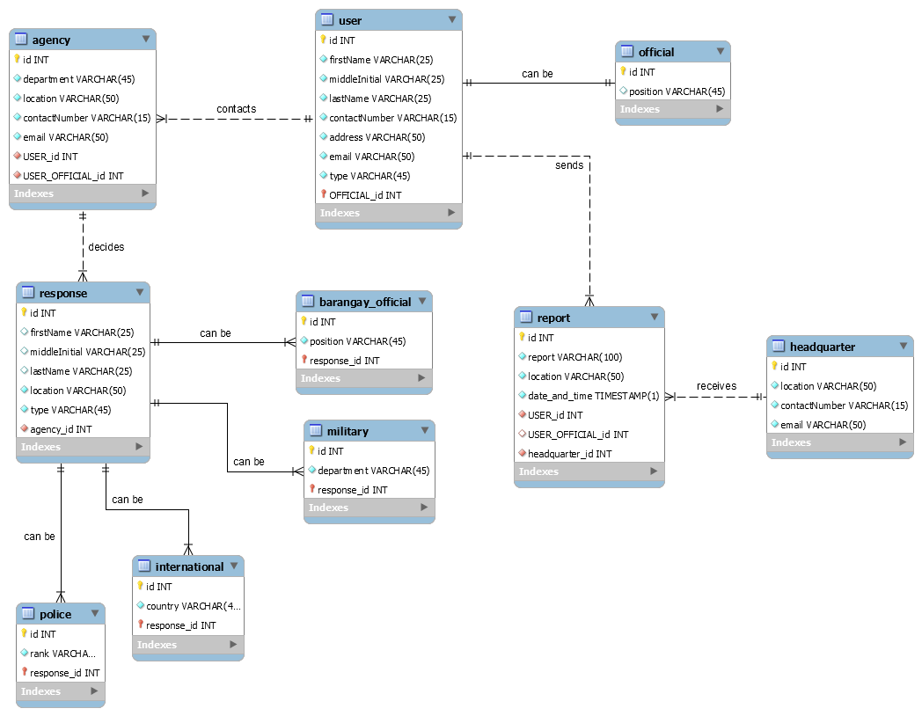

1. **Reference(s)**

(n.d.). Retrieved from ABS-CBN News: http://news.abs-cbn.com/

Authority, P. S. (n.d.). *Philippine Standard Geographic Code (PSGC)*. Retrieved from Philippine Statistic Authority: http://nap.psa.gov.ph/activestats/psgc/listreg.asp

Bueza, M. (n.d.). *The role of LGUs, local councils during disasters.* Retrieved from Rappler: http://www.rappler.com/newsbreak/44026-role-lgu-local-councils-disasters

Center(ERIC), E. R. (n.d.). *Philippine National Disaster Response Pillar*. Retrieved from Philippine National Disaster Response Pillar: http://responseops.ph/

College, A. P. (n.d.). Retrieved from Asia Pacific College Projects: http://projects2.apc.edu.ph/wiki/index.php/SOFTDEV_Projects

DEFENSE, D. O. (n.d.). *OCD Operation Manual for Response.* Retrieved from OFFICE OF CIVIL DEFENSE DEPARTMENT OF NATIONAL DEFENSE: http://ocd.gov.ph/attachments/article/144/OCD_Operation_Manual_for_Response.pdf

Defense, O. o. (n.d.). *National Disaster Risk Reduction and Management Council.* Retrieved from http://www.ndrrmc.gov.ph/

Defense, O. o. (n.d.). *Pre-Disaster Risk Asssessment.* Retrieved from National Disaster Risk Reduction and Management Council: https://mhpss.net/?get=219/Pre-Disaster-Risk-Assessment-HANDOUT_OCD.pdf

GMA. (n.d.). Retrieved from GMA News Online: http://www.gmanetwork.com/news/

Group, V. C. (n.d.). Retrieved from Voyager: https://the-control-group.github.io/voyager/

Inc., J. (n.d.). Retrieved from JotForm: https://www.jotform.com

Mcdade, j. (n.d.). Retrieved from Laravel: https://laravel.com/

*Project Quality Assurance.* (n.d.). Retrieved from Virginia Tech: http://www.itplanning.org.vt.edu/pm/qualityassurance.html

*Quality Assurance.* (n.d.). Retrieved from Project Management Skills: http://www.project-management-skills.com/what-is-quality-assurance.html

**CARL DOMINIQUE P. BUENO**

07 Jones Street, Wawa, Taguig City

cpbueno@student.apc.edu.ph

+639366993325

**Education Background:**

June 2012 – Present **Asia Pacific College**

#3 Humabon Place, Magallanes, Makati City

*Bachelor of Science in Information Technology Major in Mobile and Internet Technology*

June 2008 – March 2012 **Senator Renato Companero Cayetano Memorial Science and Technology**

**High School**

31st cor 51st Sts. Pamayanang Diego Silang, Ususan, Taguig City

June 2002 – March 2008 **Pillar of Truth Educational Foundation Inc.**

1632 M.L. Quezon Street, Taguig City

**Organizations:**

2014 **Philippine Red Cross**

Asia Pacific College

*Officer*

2012 **Junior Philippine Computer Society (JPCS)**

Asia Pacific College

*Member*

2010 **Philippine Robotics Club**

SRCCMSTHS

*Member*

**MAICA L. BELCHEZ**

123 V. Cruz St., Malibay Pasay City

mlbelchez@student.apc.edu.ph

+639153743329

**Education Background:**

June 2014 – Present **Asia Pacific College**

#3 Humabon Place, Magallanes, Makati City

*Bachelor of Science in Information Technology Major in Mobile and Internet Technology*

June 2010 – March 2014 **Pasay City Science High School**

2888 Vergel St., Pasay City

June 2004 – April 2010 **Grace Community Christian School**

754 Vitales St., Malibay Pasay City

**Organizations:**

2017 **Microsoft Community (MSC)**Asia Pacific College  
*Documentation Team – Assistant Head*

2016 **Junior Philippine Computer Society (JPCS)**

Asia Pacific College

*Member*

2016 **Microsoft Community (MSC)**

Asia Pacific College

*Documentation Team – Trainee*

2015 - Present **Junior Information Systems Security Association (JISSA)**

Asia Pacific College

*Operations Committee*

|  |  |  |
| --- | --- | --- |
| **Name:** | **JOROME L. MORTERA** | **Capture.PNG**  **2x2 CORPORATE photo**  (must fit in this box) |
| **Complete Address:**  **Contact**  **Number:** | 19 Katarungan St. Barangay Commonwealth |
| Quezon City |
| Mobile No.: (0917)929-4761 |
| **Email Address:** | jlmortera@student.apc.edu.ph  joromemortera14@gmail.com |

|  |  |
| --- | --- |
| **Objective/s** | To seek any challenges that I can use my knowledge and skills in my specialization. |
| **Education** | **Asia Pacific College**, Magallanes, Makati City  **B.S. Information Technology, with specialization in Mobile and Internet Technology**  June 2013-present |
| **Work-Related Courses** | * Applied Project * Data Communications & Data network * Database Management * IBM Descriptive Analytics * IBM Predictive Analytics * Information System Security * Introduction to System and Design for IT-MI * Management Information Systems and IT Trends * Mobile Application and Mobile Programming * Programming Embedded Systems |
| **Academic Projects** | **Diego Silang: Tearing the Chains of Slavery, June 2015**  Mobile Game Application  This group project involves making a mobile game application that is based on one of the national heroes of the Philippines. The proponent was tasked with animation and GUI design.  **Aruga at Kalinga Foundation – Crowd Funding website , June 2016 – present**  The main objective of this project is to create a website that will advertise every project of the foundation for the less fortunate, look for possible donors and monitor the progress of each project, The main features of the website are the transparency transaction and the easiest way to donate funds. The proponent’s task is to design a website that will meet the foundation’s objectives.  **NDRRMC Law and Order Response Team , January 2017 – Present**  The main objective of this group project is to create an application that will help the people when it comes to a disaster situation and to provide peace and order to the place where calamities happened. The proponent’s task involved research about the law when there is a calamity, database and software that can be used when there is no internet and no network. |
| **Technical Skills** | * MS Office: Word, Excel, PowerPoint * Web Design * Web Programming * Develop Android Application |
| **Seminars & Trainings Attended** | * Office 365 Tips and Tricks   Asia Pacific College, July 2016   * Devcon   Asia Pacific College, September 2013 |
| **Extra-Curricular Activities** | * Task Force Youth and Development (SK), Youth President, 2013 – Present; * Task Force Youth and Development Organization, Youth Leader, 2014 – Present |

|  |  |  |
| --- | --- | --- |
| **Name:** | **ABIGAIL MALAPO** |  |
| **Complete Address:** | 37 Bayabas St. Comembo |
| Makati City |
| **Contact Number/s:** | Landline: 779-1467 |
| Mobile No: (0929)312-7710 |
| **Email Address:** | amalapo@student.apc.edu.ph  abigailmalapo@gmail.com |

|  |  |
| --- | --- |
| **Job Objective** | To obtain an internship in an IT industry where I can utilize my analytical, web designing and programming skills to achieve the goals of the company |
| **Education** | **Asia Pacific College**, Magallanes, Makati City  **B.S Information Technology, major in Mobile and Internet**  June 2013-present |
| **Work-Related Courses** | * Applied Projects * Database Management * Descriptive Analytics * Fundamental of Business Analytics * Fundamentals of Enterprise Data Management * Graphical User Interface Programming * Introduction to System Development * Management Information Systems & IT Trends * Mobile Application and Mobile Programming * Predictive Analytics * Systems Analysis and Detailed Design |
| **Academic Projects** | **“Crowd Funding for Aruga at Kalinga Foundation”**  June 2016 – Present Web Application  This project is like a fund raising done through the Internet and its purpose is for donors to have an easy way of donating and monitoring the progress of each project of the foundation. For this project the proponent was assigned as the documentation controller, web designer and database encoder  **“Pack My Kit-ty”,** June 2016 – September 2016 Mobile Game Application  This project involves making a mobile game application for disaster preparedness. The proponent in this group project is involved in animations and GUI design  **“** **NDRRMC Law and Order Response Team”**,  January 2017 – Present  This group project is about how peace and order will be implemented in a community during and after a disaster. It will also be useful for the authorities when handling the situation. The proponent’s task is to research about the law and the population’s statistics. |
| **Technical Skills** | * MS Office: Word, Excel, PowerPoint * Web Designing (HTML, CSS) * Web Programming (PHP, Java) * Develop Android Application |
| **Seminars & Trainings Attended** | * Office 365 Seminar, Asia Pacific College, July 2015 * Android Seminar, Asia Pacific College, September 2014 * Devcon, Asia Pacific College, September 2013 |
| **Extra-Curricular Activities** | * JPCS, Member, SY 2013-2014 |